Special Edition, Inc.
THE BECK SPYDER – AVAILABLE IN AIR & WATER COOLED VERSIONS
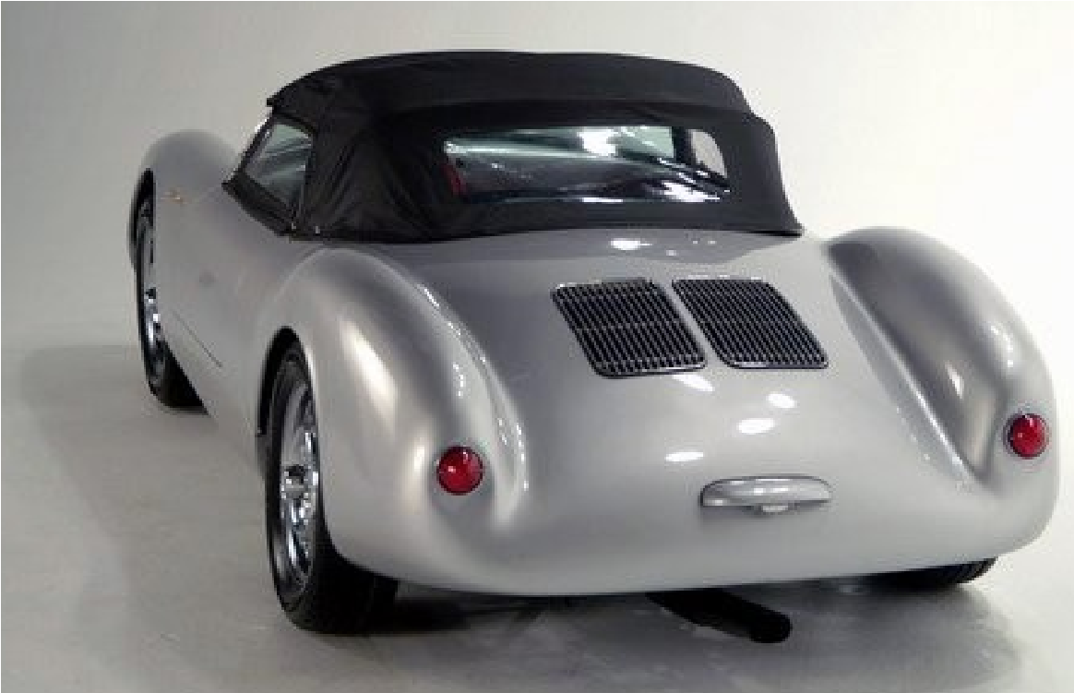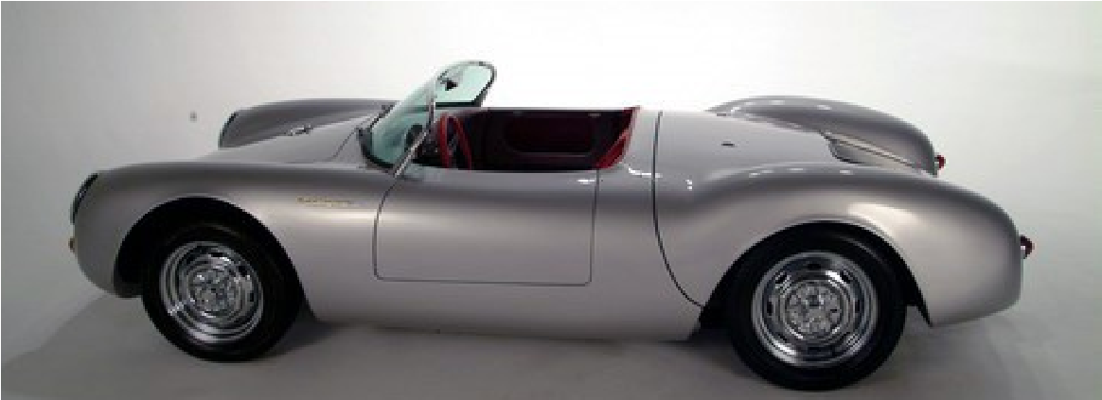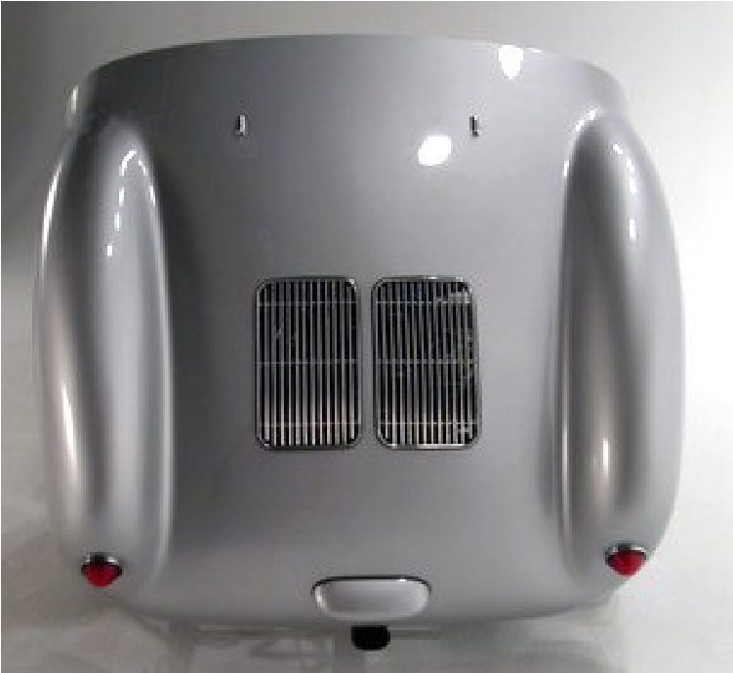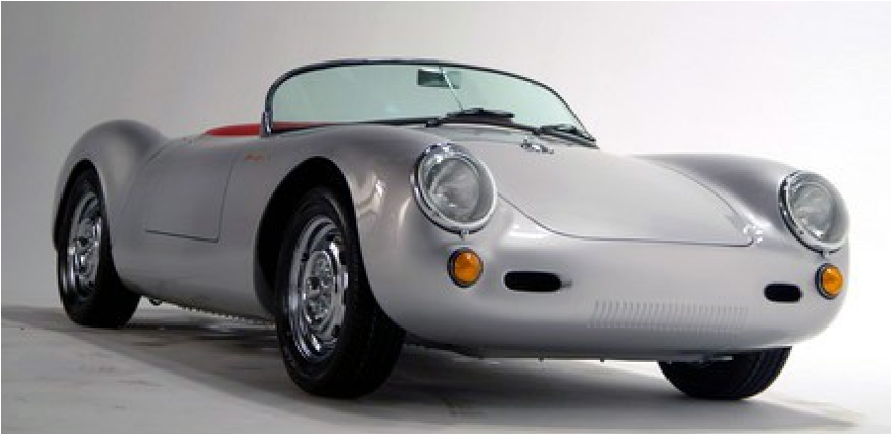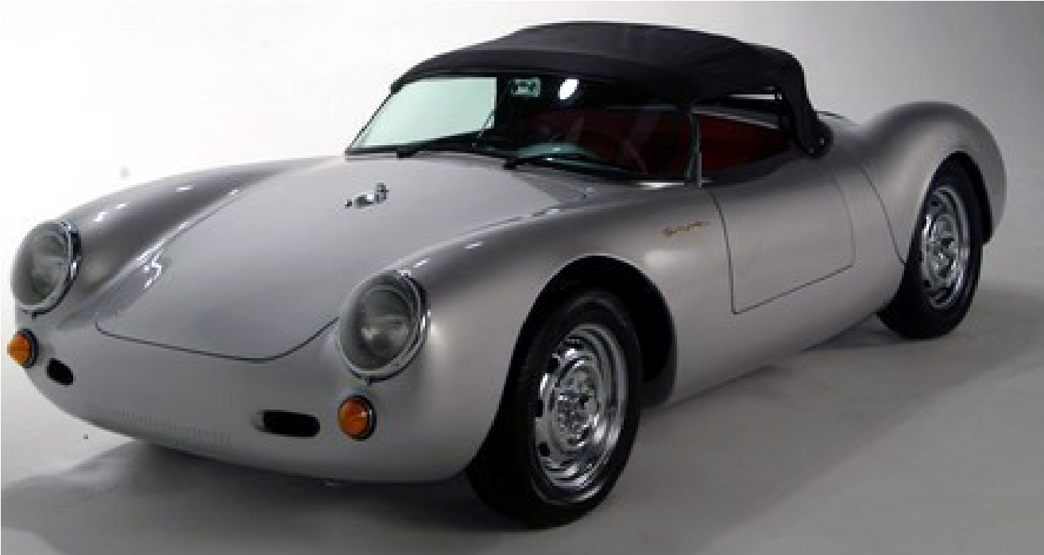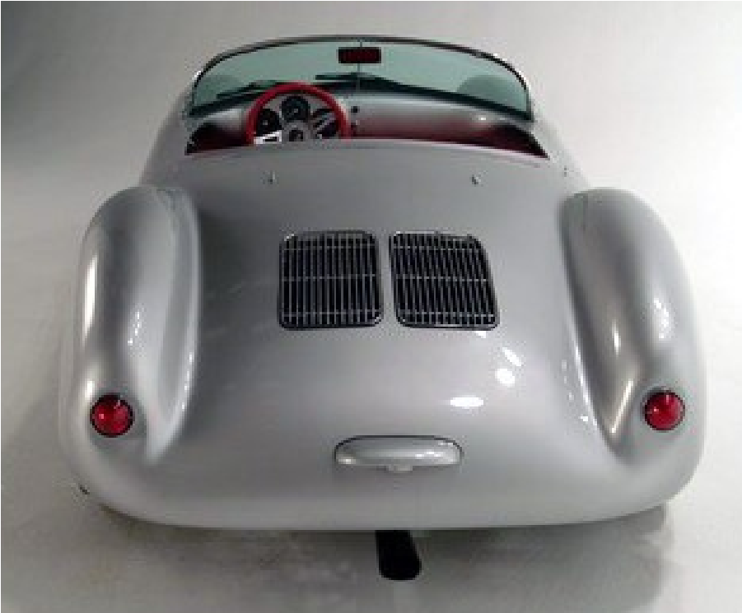
Special Edition, Inc.
119 N. Liberty Drive
Bremen, Indiana 46506
(574)546-4656 - Shop
www.BeckSpeedster.com

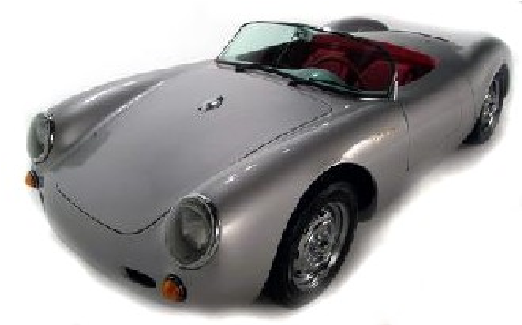
Special Edition, Inc.
Home of the BECK Products
Special Edition, Inc. was formed in the early
1980's and has been instrumental in the evolution of
the Specialty Automotive industry. By 1986, Kevin Hines of Special Edition, Inc. and Chuck Beck of Beck Development formed a partnership and the concept of easy to complete, high quality specialty cars was born.
Our engineering methods and unparalleled design criteria combine to produce a superior product that will provide years of driving excitement. Our world wide reputation for quality, honesty and extraordinary customer service is the result of 30+ years of dedication to our BECK products and the people who love them.
Standard Features:
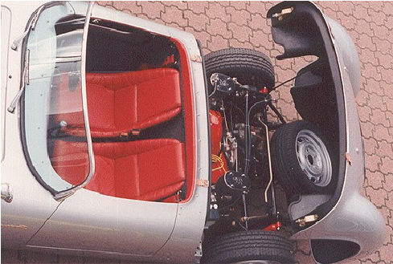
- Full Leather Interior o Hand Laid Fiberglass Body o 3” DOM Tubular Chassis o Retractable Seatbelts o Full Size Spare
- Manual Scissor Top w/Matching Side Curtains o (5) Painted Steel Road Wheels o 12,000 miles/ 12 month warranty
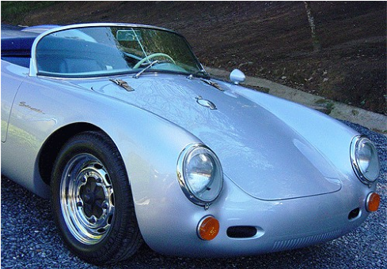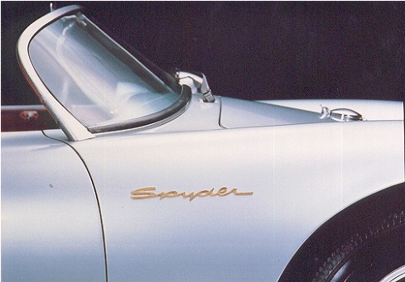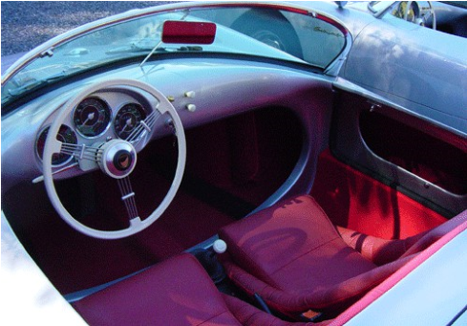
Special Edition, Inc.
119 N. Liberty Drive
Bremen, Indiana 46506
(574) 546-4656 - Shop www.BeckSpeedster.com

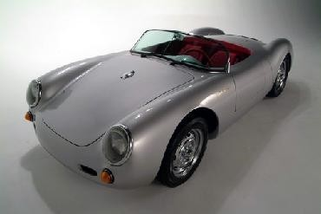
Beck Spyder
Specifications:
Wheelbase: 85" [2.16 m]
Height: 40" [1.02 m]
Length: 146" [3.71 m]
Width: 61" [1.55 m]
Curb weight: 1300 lbs [590 kg]
Standard engine: customer specific
Front suspension: fully adjustable twin torsion I-beam
Rear suspension: | Torsion bar with adjustable spring plates.
Brakes: | Front disc, rear drum and handbrake on rear wheels.
Wheels: | Painted steel road wheels 15" x 4.5" front and 15" x 5.5" rear
Tires:  Performance*: | 165/80-15 front, 195/60-15 rear [plus one spare]
Standing Start: | 0-60 mph in 5.8 seconds
Quarter mile: | 13.6 secs @ 92 mph/148 kph
Top speed: | 130 mph [209 kph]
*with a CB Performance 1915cc 125 hp engine and standard gearbox/axle ratios. Contact your local dealer to learn about available high performance options.

Interior Color Options
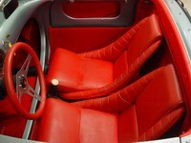
Interiors are manufactured right here at the BECK factory and are available in a wide variety of leather colors.
BRIGHT RED is most
The BECK Spyder 550 comeS standard with a leather interior,
including the seats, gear shifter, and emergency brake boot. The leather hides are carefully selected to ensure years of durability and comfort . | popular, but Black, Tan, Blue, and others are available upon request.
Exterior Paint Options* *Custom colors available upon request and consultation.
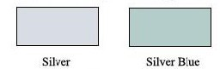
Disclaimer: We have made an effort to provide paint chips that closely represent the colors. However, due to all the possible variants -- light source, monitor quality, etc. -- we cannot guarantee that the images accurately represent the true colors. Please take this into consideration.

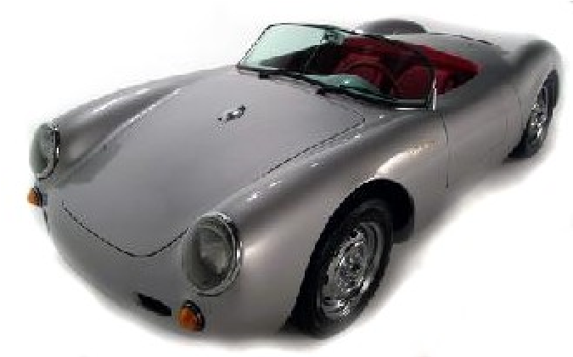
Special Edition, Inc.

Home of the BECK Products
Deluxe Pre-Assembled Body Package
Starting at $24,495.00
F.O.B. Bremen, Indiana
What is it?
The “DELUXE PRE-ASSEMBLED BODY PACKAGE” program provides the specialty automotive
enthusiast with a quality product, in a complete and comprehensive package. This alternative affords a savings over the “Roller” or “Turn Key” versions by allowing you, the customer, to supply a portion of the parts and labor relating to the final assembly procedure, yet does not demand an inordinate amount of specialized skills or professional assistance such as painting, wiring, and upholstery.
This package includes ALL of the following:
- The complete hand-laid fiberglass body, painted with Automotive quality base coat/ clear coat. The doors, front hood with support rod, and rear deck lid with support rod are hinged, latched, weather stripped and fully adjusted.
- The body comes pre-mounted to a 3” tubular steel frame that is an integral part of the body/chassis system. It includes a fully adjustable front axle beam with torsion bars installed and rear suspension components complete to the spring plate assemblies. Tubular steel is an extremely strong method of construction and gives the Spyder excellent torsional rigidity resulting in crisp handling, consistent door gap, and superior fit and finish.
- The self-parking, 2-speed windshield wiper system is completely installed and wired.
- All of wiring is completely installed. This includes the 3-gage cluster, all switches, relays, engine harness, lighting and a complete fuse panel. The steering column with turn signal, emergency flasher and wiper switch is installed.
- The removable convertible top and steel scissor mechanism is completely assembled and operational.
- All latches, hinges, and release cables are installed and fully adjusted.
- Full leather interior is completely installed including original style, slotted bucket seats, leather wrapped steering wheel, shifter and parking brake boots.
- The interior is completely carpeted.
- The accelerator, parking brake, and clutch cables are installed. The cable shift mechanism is complete and pre-installed.
- The fuel tank, aluminum “Quick fill” gas cap, and fuel lines are installed. o Pedals, dual circuit master cylinder, reservoir, and brake lines are all installed.
The “DELUXE PRE-ASSEMBLED BODY PACKAGE” is extremely complete. The builder need only
supply the engine of his choosing, a transaxle, brakes, wheels, tires, lights, fluids and some hardware (most items available in the optional packages), some basic mechanical ability and approximately 25 to 30 hours of assembly time.
Prices are subject to change without notice. A $5,000.00 deposit must accompany all orders. Please call for availability.
Special Edition, Inc.
119 N. Liberty Drive
Bremen, Indiana 46506
(574) 546-4656 - Shop
www.BeckSpeedster.com
Effective January 22, 2021
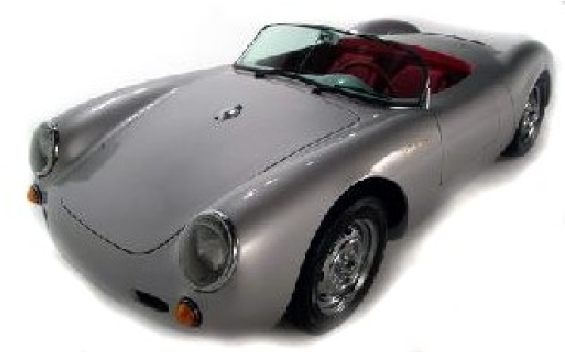
Special Edition, Inc.

Home of the BECK Products
DELUXE “ROLLER” PACKAGE
Starting at $34,865(less engine)
F.O.B. Bremen, Indiana
What is it?
The “Deluxe Roller Package” comes “rolling” to your door, ready to accept the engine you choose.. This package is ideal for someone who has a very specific engine supplier or desire to install a unique type of power train (i.e. battery operated) into our Beck Spyder.
This package includes ALL of the features of the “Deluxe Pre-assembled Body Package”, plus the following items:
- A 4-Speed manual transaxle of your choice. (All transaxles are the swing axle style but may be modified with high performance parts, a variety of gear sets, and upgraded from drum to disc brakes for an additional charge.)
- The brake system is complete and operational, as is the parking brake system. Fine tuning of the alignment is still required.
- The steering components are completely installed and operational.
- Head & taillights, turn signals and license plate light are installed and wired.. o The engine harness is in place and ready to be attached to the motor.
- A set of 5 wheels and tires are mounted and balanced. Tire brands may vary with availability. Tire upgrades are available at additional cost.
- The side & rear view mirror are installed, along with the horn grills. o “Spyder” badges are installed, left and right.
- Other optional items may be ordered and pre-installed as well. Please see the MSRP sheet for a list of our most popular add-ons.
Pricing Breakdown:
Deluxe-Body Package………………………………………………………………...$24,495
Roller Package Assembly Fee (Partial)……..........…………………………….…........$3,250
Standard 4-speed manual Pro Street 4.12 Ring & Pinion transaxle ……….…......$2,450
Wheel and Tire Package..................................................................................................$1,495
3 completion packages………………………………………………………………….$3,175
Total: $34,865. (less engine)
Prices are subject to change without notice. A $ 5,000.00 deposit must accompany all orders. Please call for availability.
Effective January 22, 2021
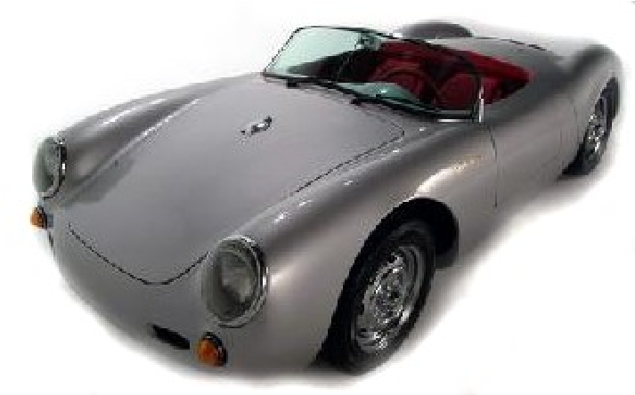
Special Edition, Inc.

Home of the BECK Products
BECK SPYDER CUSTOMER - ASSEMBLY DETAIL
Complete my Beck Spyder 550 as:
Pre-Assembled A Deluxe Roller
Body Package “Turn-Key”
The engine option I want is a:
1915cc Hi-Po 2165 cc Other ________
This engine is being built by ______________________________. (Engine Company Name)
NOTE: Special Edition, Inc DOES NOT supply or install engines.
Stock Exhaust Stainless Exhaust
Custom 1 5/8” Ceramic Other
TRANSAXLE DETAILS
Basic 4 Speed Manual Rear Disc Brake upgrade
3:88 Ring and Pinion Wide Five Bolt Pattern Upgrade
1st and 2nd gear custom ratio Other ___________________
ProStreet Upgrade
INTERIOR OPTIONS
Nardi Replica Wooden Steering Wheel 12 Volt Auxiliary Outlet
Wooden Shift Knob Other _______________________.
Dash Grab Handle (passenger side) Other _______________________.
EXTERIOR OPTIONS
Cloth Tonneau Cover w/ Tenax
Fasteners Helmet Fairing
Passenger Side Mirror – Standard Fluted Lenses
GT Racing Mirror BECK Turn Signals/Taillights
Leather Bonnet Straps Other __________________
Racing Darts (on Rear Decklid) Other__________________
Other options/Special Instructions___________________________________________________________ ______________________________________________________________________________________
______________________________________________________________________________________
______________________________________________________________________________________
______________________________________________________________________________________
______________________________________________________________________________________
______________________________________________________________________________________
______________________________________________________________________________________
______________________________________________________________________________________
______________________________________________________________________________________
Effective January 22, 2021
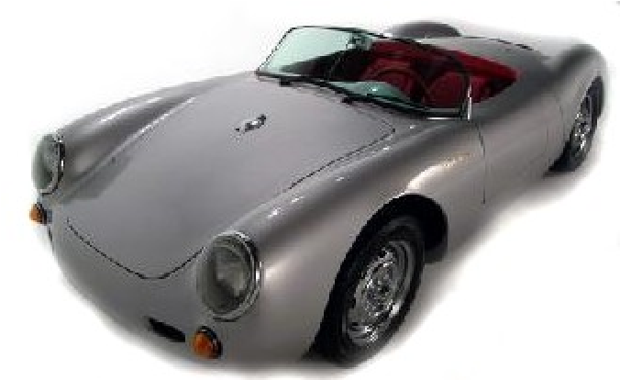
Special Edition, Inc.
Yesterday’s Classics Made for Today

Beck Spyder Customer Order Form
Use this Order form regardless of whether you are ordering a: DELUXE PRE-ASSEMBLED BODY PACKAGE, DELUXE “ROLLER” PACKAGE or “TURN-KEY”.
Name___________________________________________________
Address _________________________________________________
City___________________________ State ______ Zip________
Home Phone (___) _____-_______ Other # (___) _____-________
E-mail Address (optional)___________________________________
“Pre-assembled Body Package”.....................................$24,495.00
“Roller” Package. ………………..................................$ 34,865.00

“Turn Key”……………………………………price by formal quote only
I am submitting additional options on a separate Assembly Detail Sheet. (Attached) Paint Color Choice*:
Metallic Silver Silver Blue __ Other
*Custom colors available upon request. Additional fees may apply. Please call for assistance or enter Sikkens Paint code here: _________________
Interior Color Choices: Top:
Black Interior: | Other_______
Black  Bright Red | Whiskey Tan Other | Navy Blue
A $5,000.00 deposit is required with your order.
________________________________ ____________
Customer Signature Date
________________________________ ____________ Dealer Acceptance (required for Turn-Key vehicles) Date
This signed agreement represents formal acceptance of Dealers offer. This price sheet is effective January 22, 2021 and is subject to change without notice. The manufacturer reserves the right to make changes at any time, without notice or obligation, in colors, specifications, materials, models and prices.
Special Edition, Inc.
119 N. Liberty Drive Bremen, IN 46506

