
Special Edition, Inc.
Beck GTS

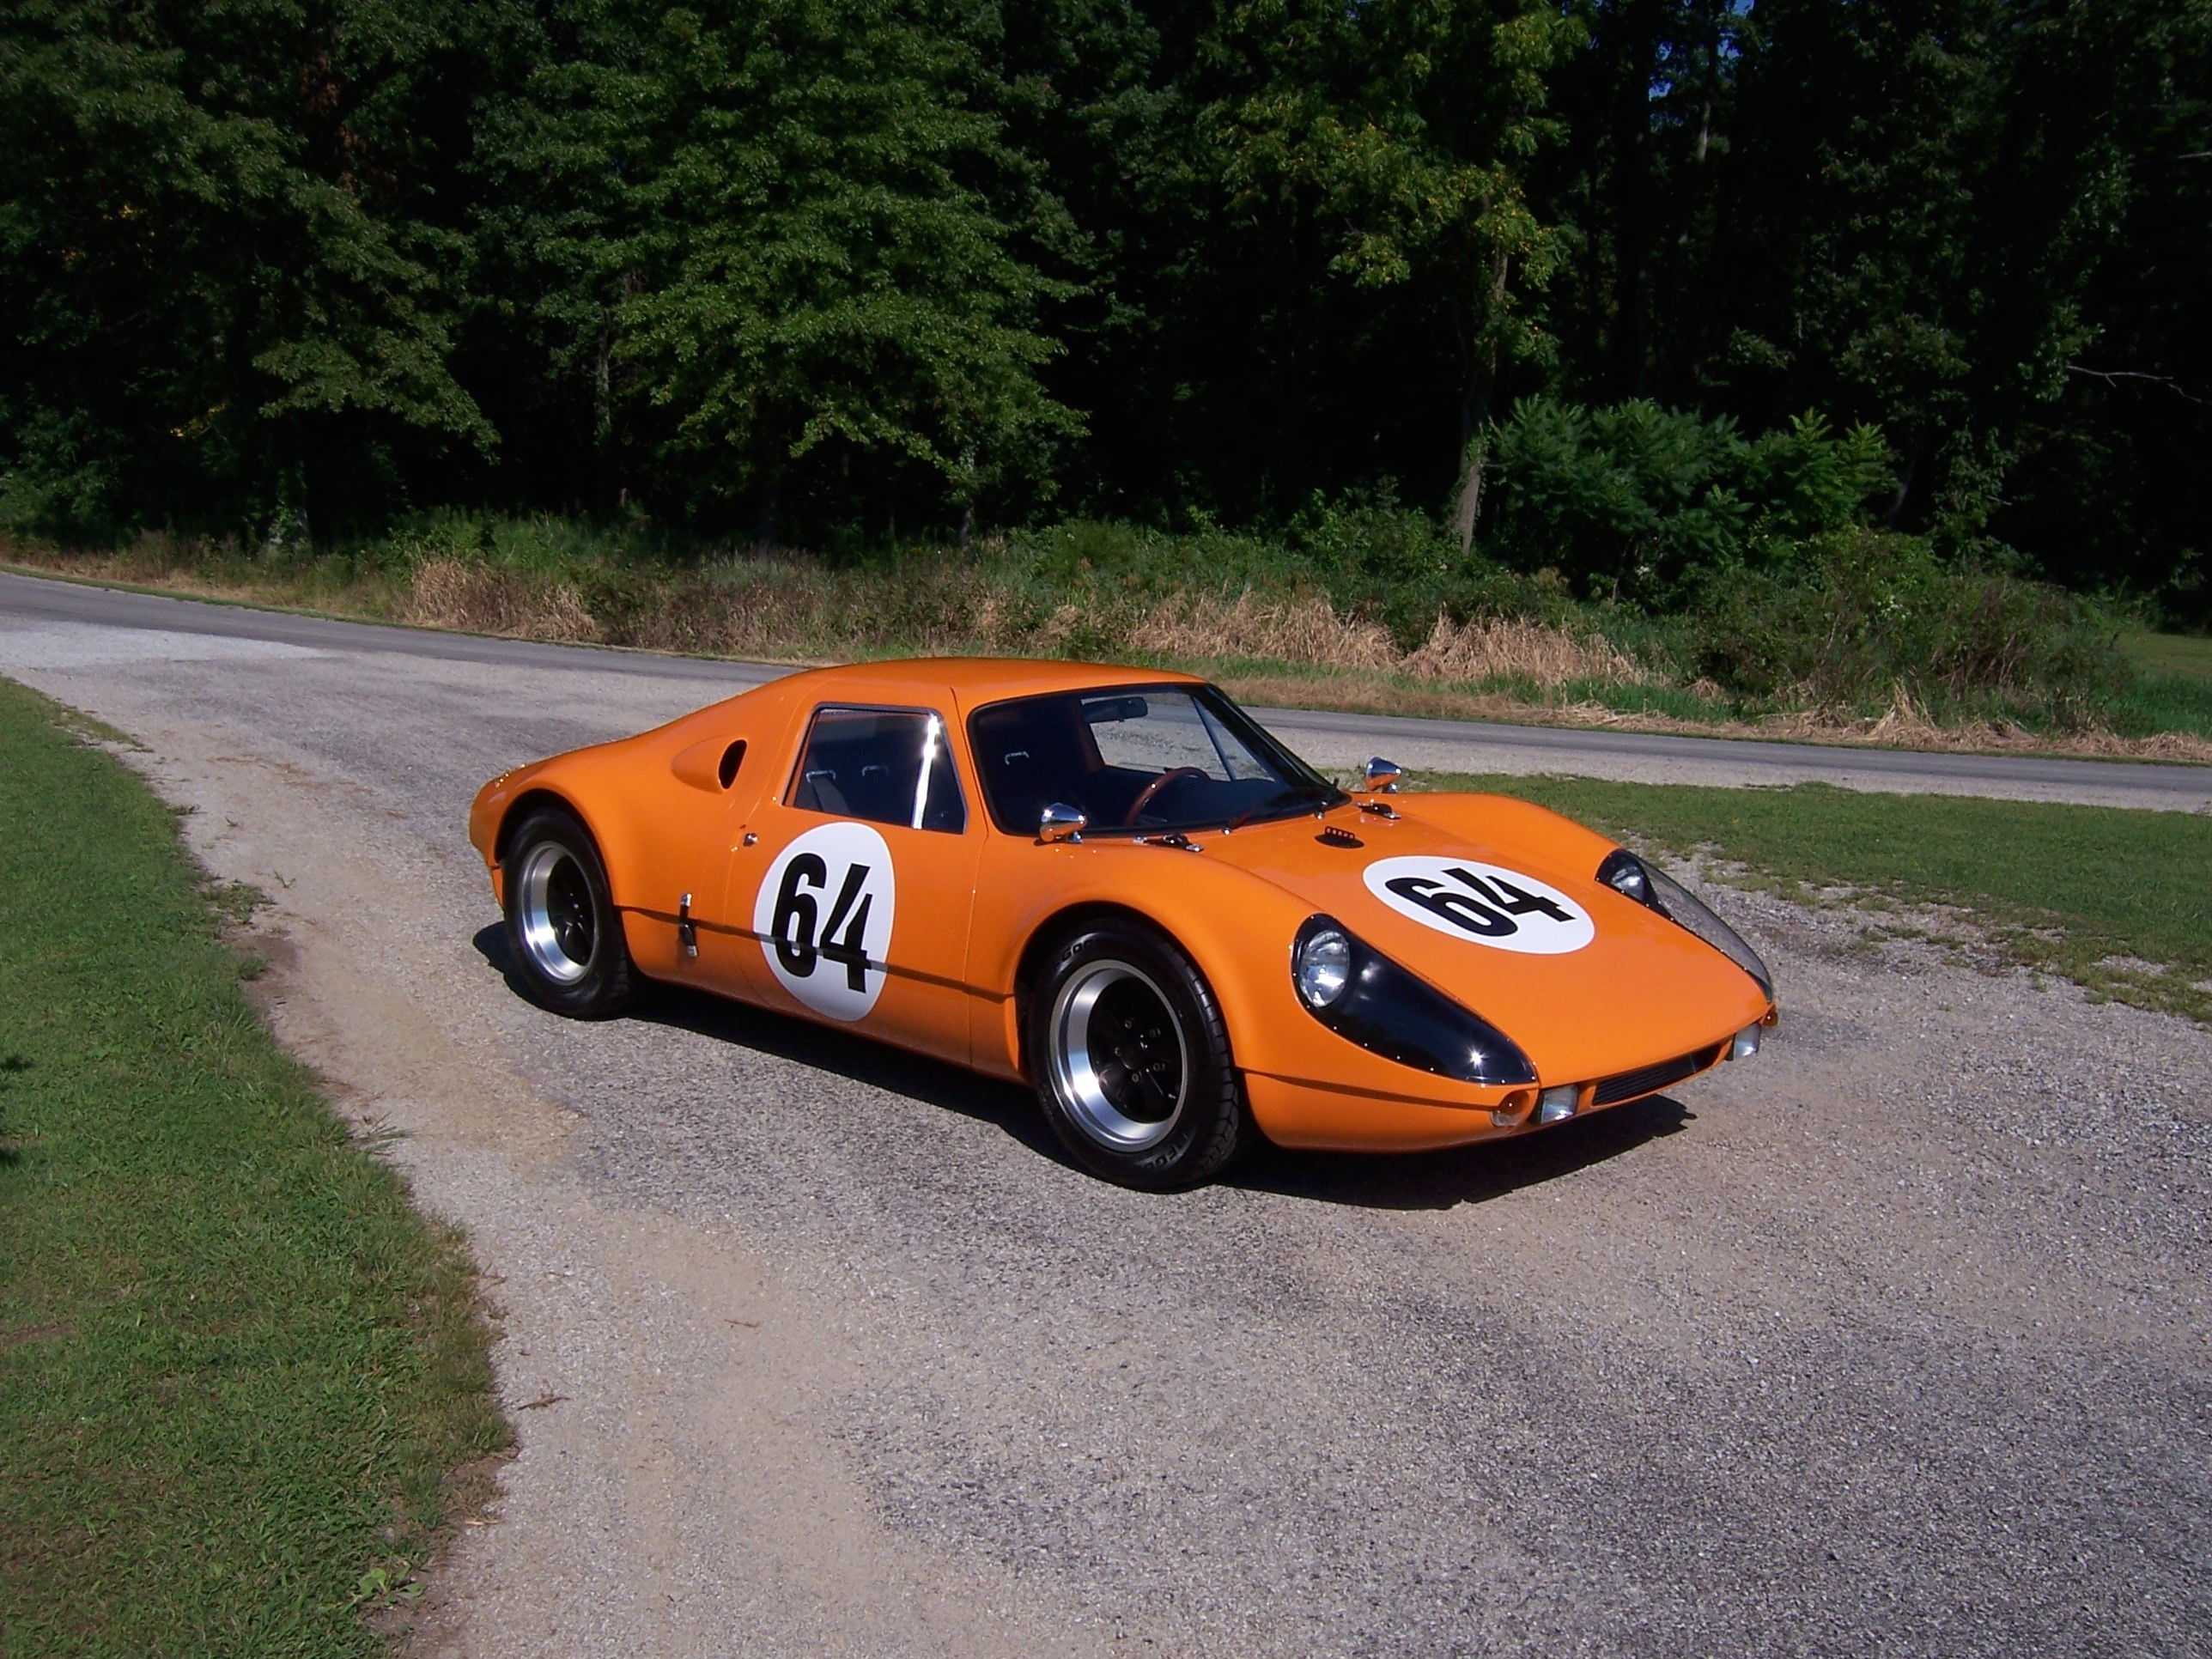
Special Edition, Inc. 119 North Liberty Dr Bremen, IN 46506
574-546-4656 shop www.beckspeedster.com

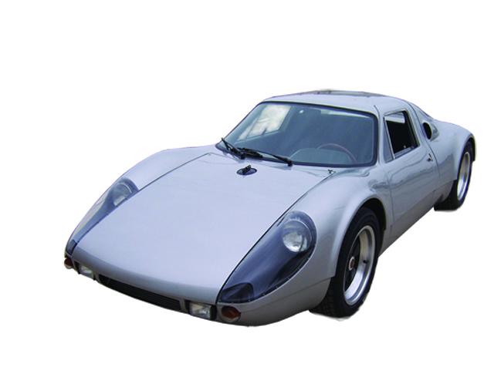 Special Edition, Inc.

Special Edition, Inc. was formed in the early 1980's and has been instrumental in the evolution of the Specialty Automotive industry. By 1986, Kevin Hines of Special
Edition, Inc. and Chuck Beck of Beck Development formed a partnership and the concept of easy to complete, high quality component vehicle was born.
Special Edition, Inc. is the national manufacturer and distributor for all Beck products.
Our engineering methods and unparalleled design criteria combine to produce a superior product that will provide years of driving excitement.

GTS standard features
- hand laminated fiberglass body
- high quality base coat/clear coat paint in your choice of color
- stainless steel chassis and floor; folded stainless sheet, boxed main rails, and tubular steel
- attractive/functional period correct interior finished in leather
- authentic VDO instruments in a vintage style
- genuine Hella lights
- period correct fog lights
- front mounted oil cooler, braided stainless lines, A/N fittings
- manual rack and pinion steering
- Chevron B-16 inspired suspension
- CNC aluminum uprights, front and rear, disc brakes
- set up for any air-cooled flat 6 donor engine and 901/915 gearbox (special applications also available)
- 16x8 and 16x9 Fuchs wheels (vintage style and custom wheels available)
- hand made, light weight, aluminum fuel tank
- individually hand built, in limited quantity, to customer specifications with the same quality and care you’d expect from the Beck brand

Special Edition, Inc. 119 North Liberty Dr Bremen, IN 46506
574-546-4656 shop www.beckspeedster.com
Special Edition, Inc.

Beck GTS Specifications

DESCRIPTION | BECK GTS
Body type | Coupe
Body material | Fiberglass
Fabrication method | Hand laid
Attachment method | Bonded
Brakes | 4 wheel disc
Caliper material | Aluminum
Pistons per caliper | 2
Front rotor diameter | 12”
Rear rotor diameter | 12”
Chassis construction | Boxed ladder
Box section dimensions | 3 x 8
Fabrication method | TIG and spot welded
Floor pan material | Stainless steel
Frame material | Stainless steel
Nose cone stiffener | Integral
Roll bar | Integral
Full roll cage with door bars | Optional
Drivetrain power delivery | RWD
# of gears | 5
Transaxle type | Manual
Engine type* | Air cooled
Cylinders | 6
Cylinder arrangement | boxer
Compression ratio | 12:1
Displacement | 3164
Gross power (hp) | 275
Torque (ft/lbs) | 240
Net power (whp) | 250
Front suspension | Dual tubular A arm
Shocks | Coil-over
Uprights | CNC billet aluminum
Rear suspension | 4 link w/parallel trailing arm, bottom mounted A arm
Shocks | Coil-over
Uprights | CNC billet aluminum
Tires, front | 225/50ZR16
Tires, rear | 255/50ZR16
Wheels, front | 8Jx16
Wheels, rear | 9Jx16
Curb weight, lbs | 1720
Weight distribution | 48/52
Length | 164”
Width | 63”
Height | 42”
Wheelbase | 91”
Performance specs | Based on 3.2L 6cyl
Coefficient of drag | 0.33
Lateral acceleration | 1.14
Specific power (hp/ton) | 290
0-60 time | 3.6s
¼ mile time | 12.6s
Top speed | 175

*All Beck performance specs based on Chuck Beck’s GTS test mule with a 3.2L engine dyno’d at 250 whp, tested by “Dream Car Garage” at Road Atlanta. Available configurations for ANY air cooled flat 6 engine from 2.0L to 3.6L and beyond, provisions possible for watercooled flat 6 (track only), Subaru flat 4 and 6, and VW flat 4 engines, inquire for details.

Special Edition, Inc. 119 North Liberty Dr Bremen, IN 46506
DELUXE “ROLLER” PACKAGE Starting at $70,000. (less engine/gearbox)
F.O.B. Bremen, Indiana

***please note that, at this time, we do not offer (nor do we plan to offer) a less complete “kit” for the GTS. The roller package is the most incomplete that we are offering at this time.

What is it?
The “Deluxe Roller Package” comes “rolling” to your door, ready to install your engine and gearbox. This package is ideal for someone who has a very specific engine supplier or donor parts to install into our Beck GTS.
Integral body/chassis are mated and fully adjusted, painted in basecoat/clear coat.
All doors, hood and rear clamshell are hung, weather stripped and adjusted.
Windshield, side glass and rear plexi are trimmed, sealed, installed and adjusted.
The brake system is complete and operational, as is the emergency brake system. Fine
tuning of the alignment may still be required.
The steering and suspension components are completely installed and operational, including a Nardi replica wood steering wheel and vintage turn signal unit.
Pedal assembly and related cables/hoses are installed and ready.
Windshield wiper assembly is installed and adjusted.
Head & taillights, turn signals and license plate lights are installed with completed
wiring.
Interior is complete, in your choice of color, with completed dash and instruments.
The engine harness is pre-wired, in place, and ready to be attached to the DME/motor.
Custom rod shifter is fabricated based on your intended gearbox choice and pre installed.
A set of 4 tires are mounted and balanced.
The side & rear view mirrors are installed.
Note: Other optional items may be ordered and pre-installed as well. Please see the order sheet for a list of our most popular add-ons.

How will I get my Beck GTS?
This package can be transported by an automotive carrier service. They generally charge a small additional fee for handling “non-runners”. Please call for an estimate.

Prices are subject to change without notice. A $10,000.00 deposit must accompany all orders. Please call for availability and current production schedule.

Special Edition, Inc. 119 North Liberty Dr Bremen, IN 46506
574-546-4656 shop www.beckspeedster.com
Frequently Asked Questions (FAQ's)
Q: What about your production makes the GTS a “limited production” compared to your other offerings?
A: While we produce around 100 Beck Speedsters and Beck Spyders per year, the Beck GTS is individually, and completely, built at the time of order. In the few years we have offered the GTS, all cars have been pre-sold well ahead of our production schedule.
Q: What stages of completion do you offer?
A: While we offer three separate stages for our Speedster and Spyder, we only offer 2 stages for our GTS.
1) The "roller" package, which is ready to accept the engine and gearbox of your choice
2) The "turn-key" package. Although Special Edition, Inc. DOES NOT directly supply engines
or gearboxes, it is still possible for the customer to receive a tested and ready to drive GTS.
Q: What type of engine and gearbox can I use?
A: The Beck GTS is set up for any air-cooled flat 6 engine of nearly any displacement, and the 901 or 915 series of gearbox. Other engines and gearboxes can be adapted, and in most cases we can set the roller up for an easy install of your custom motor.
Q: What are the most popular engines? What is the biggest engine I can use?
A1: The 3.6L seem to be the engine of choice for most of our clients. That said, we have used nearly every flat 6 mill, including a few INSANE turbo motors… We’ve even done all electric!
A2: The engine size/hp is limited only by budget and sanity.
Q: I have seen other companies that offer a tubular frame vs. the folded sheet/tubular hybrid. How is yours different?
A: The Beck GTS is the only one of its kind that uses a folded stainless steel chassis.. While much more difficult to manufacture, the Beck chassis is the most robust, torsionally rigid, track proven chassis you will find. The integral nose cone stiffener and modern suspension combined with Beck craftsmanship make the Beck GTS handle like a modern track car, while keeping a vintage appearance.
Q: How do I insure my Beck GTS?
A: If your current carrier does not have the ability to insure your new vehicle, several companies specialize in insuring specialty vehicles. Hagerty comes recommended and can be contacted at 1-800-922-4050 or
www.hagerty.com.
Q: How do I register my Beck GTS?
A: Registration is not federally regulated, so it varies from state to state. You will need to check with your
local BMV for your state's requirements. However, Beck products have been successfully registered in all
50 states.
Q: Does the Beck GTS come with a warranty?
A: Yes! We offer a 12 month/12,000 mile limited warranty. This covers your GTS's contents and
workmanship. The drivetrain components, as well as a few of our optional components, carry a warranty
directly from their respective manufacturers/rebuilders. Sorry, we cannot warranty track cars.
Q: How does the Beck GTS hold up in resale value?
A: We have seen our products hold their value very well over the last 25 years. According to the Kelly
Blue Book, the average car loses 65% of its value in the first 5 years. We have seen our products sell as
high as 100%-120% of their original value, 10 years down the road!
Q: Do you offer financing?
A: Financing can be obtained through J.J. Best Banc & Co. Call 1-800-USA-1965 (or on the web at
www.jjbest.com).
Special Edition, Inc. 119 North Liberty Dr Bremen, IN 46506
574-546-4656 shop www.beckspeedster.com
Special Edition, Inc.

Beck GTS Customer Order Form
Use this Order form for both a DELUXE “ROLLER” PACKAGE or “TURN-KEY”.
Name___________________________________________________
Address _________________________________________________
City___________________________ State ______ Zip________
Home Phone (___) _____-_______ Other # (___) _____-________
E-mail Address (optional)___________________________________

- I am submitting options on a separate Assembly Detail Sheet. (Attached)

Color Choices:
Paint:
○ Beck Silver ○ Beck Silver-blue ○ Custom color, please fill in below
Please specify color and paint code; ___________________________
**please note that some special colors, such as tri-coats, flats, or pearls will have an additional charge based on the specific paint.

Interior
Carpet color: ○ Black ○ Red ○ Gray
○ Custom color, please specify___________________________

Leather color: ○ Black ○ Red
○ Custom color, please specify _________

A $10,000.00 deposit is required with your order.
________________________________ ____________
Customer Signature Date
________________________________ ____________
Dealer Acceptance (required for Turn-Key vehicles) Date

Special Edition, Inc. 119 North Liberty Dr Bremen, IN 46506
574-546-4656 shop www.beckspeedster.com
Special Edition, Inc.

Beck GTS Customer Options Form
I would like to receive my Beck GTS as a ○ roller, as a ○ turnkey.

○ I have an engine, harness, DME, and gearbox that I will be sending
○ The engine and gearbox are ready to go.
○ I would like to use Chuck Beck’s engine rebuilding service.
○ I would like to speak with someone about getting an engine/gearbox.

The engine I plan to use is: __________________________
The gearbox I plan to use is: ○ 901 ○ 915 ○ Other, specify ___________

I would like the inside of the headlight buckets painted ○ black, ○ body color.
Fuel filler location:
○ hidden (stock) ○ through hood (center) ○ through hood (passenger side)
Seat belts:
○ lap (stock) ○ 3 point retractable (add $250) ○ 5 point racing (add $600)
Shifter:
○ stock 901/915 shifter ○ Custom gated shifter (add $1500) ○ cable shifter (add $850)
Additional comfort and racing options:
○ Air Conditioning (add $3000)
○ Custom heater boxes and blower (add $1500)
○ Front chin spoiler (add $500) NOTE: too low for safe street use
○ Rear duck tail spoiler (add $500)
○ Front hood straps (add $250)
○ Rear bonnet straps (leather or rubber, add $250)
○ Genuine/restored Hella fog lights (add $750)
○ Rear reflectors (add $150)
○ CNC aluminum vintage style wheels (add $3500)

○ Full track pack (add $10,000) includes full roll cage, door bars, battery cut off, front and rear spoiler, 5 point racing harnesses, slightly flared body to accommodate wider rubber.

Custom options available upon request, contact us for a quote. Examples; custom engines/gearboxes, custom vinyl decals, fire suppression systems, various steering wheels, custom gauges, stereos, etc…

Special Edition, Inc. 119 North Liberty Dr Bremen, IN 46506
574-546-4656 shop www.beckspeedster.com
PHOTOS
